BMC2 2026 Coordinator Quality Improvement Project Upload Guide

- Go to the BMC2 Peer Review Uploader Website Uploader website using Chrome, Firefox, or Microsoft Edge. Do not use Internet Explorer. You will not be able to upload files using Internet Explorer.  - Enter your site number in the  Identifier field.  - Select See Case Lists. | 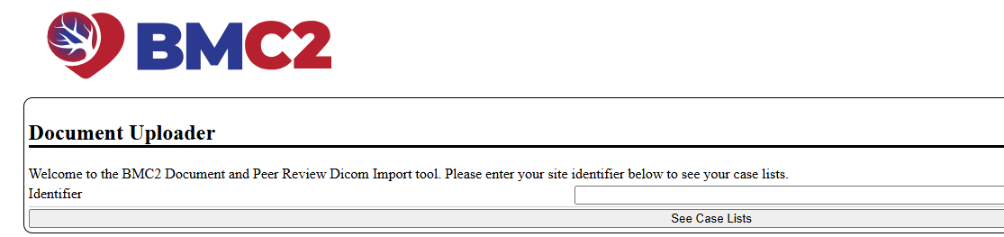
- A list of projects will display. Locate Phase: PCI-QI-2026_2027  - Click on the upload series icon that corresponds to the year of the project(s) you are  uploading. | 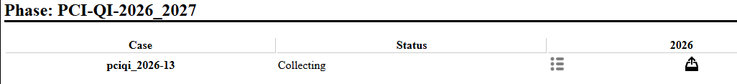
6. The Upload screen will display for the chosen year. Click on the Choose Files button. | 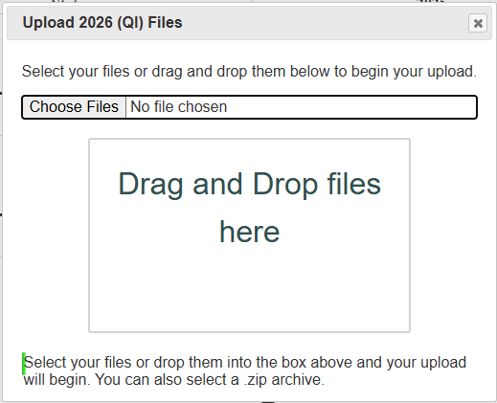
- Locate your file on your computer.  - Click on the file.  - Select the Open button or drag the file to the “Drag and Drop files here” box.  Please note that two QI summaries are required. If uploading additional files they must be in .doc, .pdf, .ppt format. | 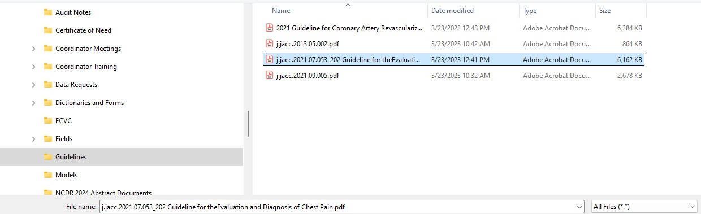

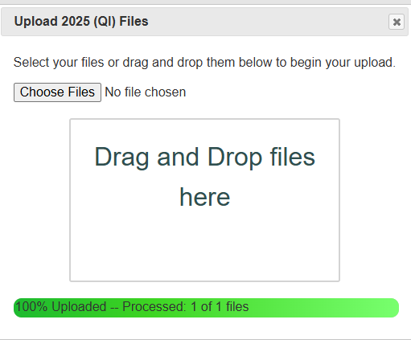
- You will see the Upload box again. You know that your file has uploaded when you see the green bar at the bottom of the box and the word "Processed" inside.
- Select the next file you want to upload for that timeframe and repeat steps 7-9. You will only see “1 of 1 files” even if you upload multiple files.
- Click on the “X” in the top right corner of your screen when you have uploaded all the files for that timeframe.
13. Click on the reload icon to refresh the page.
14. The View Series symbol will change form gray to black when files are successfully uploaded. Click on that symbol to view a list of the files you have  uploaded. |   Before:    Successful Upload:
15. View Series List contains the list of projects that you have uploaded. the same connection. | 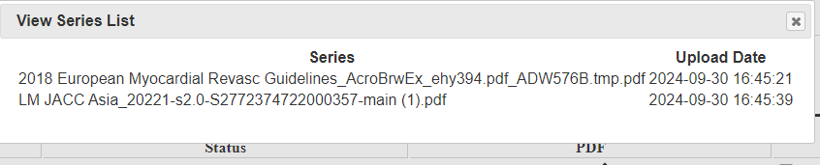
16. Repeat steps 4-15 to upload the other set of QI project files. | 